Spark Processes 100 GB File

Spark Cluster: A collection of worker nodes (physical machines)

Spark Worker Node:
- A worker node is a machine (physical or virtual) that runs executors. It has:
CPU cores → used by executors to run tasks in parallel, A Spark CPU core is one
physical or virtual CPU thread that can run one task at a time
RAM → shared by all executors on that node
- Generally 1 Core has 4 GB RAM
- Nodes configuration:
  - 4 cores, 16 GB RAM (minimum config)
  - 8 cores, 32 GB RAM
  - 16 cores, 64 GB RAM
  - 32 cores, 128 GB RAM (minimum config)

- Target 2–3× data size as total cluster memory (100GB * 3 = 300 GB total cluster size)
  - To process 100GB file we need 300GB RAM in total
  - 300 GB / 3 worker nodes = 100 GB each W-Node

NOTE: Number of worker nodes for Production: 3 for parallelism, fault tolerance

- If each worker node should process 100GB data then how many cores/ram it needs
  - 1 Core = 4 GB RAM
  - 100 GB / 4 GB RAM = 25 cores each worker node
  - But cores are 4,8,16,32 , we can configure 16 core (64 GB RAM) for each worker
  - 1 Worker Node = 16 Core , 64 GB RAM
  - 3 workers total cores and memory (16 * 3 = 48 core , 64 GB * 4 = 256 GB)

- If worker node is 16 Core , 64 GB RAM then how many executors are needed
  - Configure 3 or 4 executors for
    - parallelism
    - Avoids GC pressure
    - Avoids giant executors.
  - Let’s take 4 executors , So 16 core can be divided between 4 executors with each 4 core
  - 1 Worker node = 4 Total Executors
  - 1 Executor = 4 Core 16 GB RAM

- If 1 Executor is 4 Core 16 GB RAM then how many tasks can it have
  - Configure 4 – 6 Cores per executor for below reasons
    - Too many cores per executor cause GC overhead
    - Too few cores (1–2) waste memory and slow down jobs
  - 1 partition = 1 task = 1 core
    - 1 Partition is 128 MB to 256 MB in size
  - 1 Executor has 4 tasks (each task 4 GB RAM)

- So cluster-wide calculation for 3 worker nodes (Each node: 16 cores, 64 GB RAM)
  - 1 worker node has 4 executors
  - 1 executor get 4 core
  - 12 Total number of executors in cluster (4 executors per node × 3 w-node)
  - Total executor cores = 16 × 3 = 48 cores
  - Total memory for executors = 64 GB × 3 workers = 192 GB
  - Spark submit options
--num-executors 12 // Total number of executors in cluster
--executor-cores 4 // Total cores for each executor
--executor-memory 16 GB // Total memory per executor
--executor-memoryOverhead 2G // Extra memory spark allocates
--driver-memory 8G
What it does: Memory for the driver JVM, which coordinates all executors,
collects results, and schedules tasks.
Why 8G: Enough for a 100 GB job where the driver mostly schedules tasks and
doesn’t collect huge datasets. For heavy collect() operations or
broadcasting large tables, increase driver memory.
--driver-cores 4
What it does: Number of CPU cores assigned to the driver for scheduling and task
management.
Why 4: Allows driver to schedule tasks efficiently without being a bottleneck.
2–4 cores is typical; more only needed for extremely large jobs.
--conf spark.sql.shuffle.partitions=400
What it does: Sets the number of partitions for shuffle operations (joins, groupBy,
aggregations).
Why 400:
100 GB data / 256 MB partition → 400 partitions
Matches the optimal partition size rule
Ensures parallelism without too many tiny tasks.
--conf spark.default.parallelism=400
What it does:
Sets the default number of partitions for RDD operations (like map, filter).
If not set, Spark defaults to 2 × number of cores.
Why 400:
Matches shuffle partitions
Ensures enough parallelism for 45 cores → ~9 waves of tasks

Parallelism (Spark Partitions)

Rule of thumb: 4 partitions per executor
You have 45 cores → target:

90–180 partitions minimum
For 100 GB data:

Good partition size = 256 MB
→ 100 GB / 0.25 = 400 partitions
So set:
spark.conf.set("spark.sql.shuffle.partitions", 400)
spark.conf.set("spark.default.parallelism", 400)
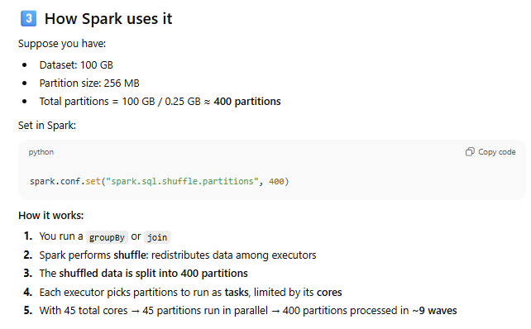

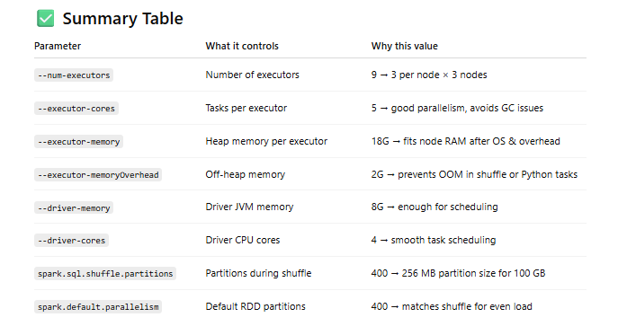

Spark File is divided into partitions and distributed into worker’s in memory RAM for parallel processing
  - 1 Partition is 128 MB – 256 MB
  - These two sizes are industry standard because they balance:
    - Parallelism
    - Shuffle cost
    - Memory usage per task
    - Spill reduction
.

Summary: How Partition Size is actually configured:

Spark controls partition size indirectly using a few settings that determine how many partitions it creates.

Partition Size When Reading Files (input partitions) : For text, JSON, CSV, ORC, Parquet

Spark reads files in chunks determined by: spark.sql.files.maxPartitionBytes

Default: // 128MB min and 256MB max

To set partition size = 256 MB:

spark.conf.set("spark.sql.files.maxPartitionBytes", <<256 * 1024 * 1024>> bytes = 256 MB)

Shuffle Partition Size (after joins, groupBy, etc.)

When Spark shuffles data, the number of partitions is controlled by:

spark.conf.set("spark.sql.shuffle.partitions", 200) // Default: 200

For your 100 GB data:

To target ~256 MB partition size: 100 GB / 256 MB ≈ 400 partitions

RDD API (if you're using sc.textFile / map / reduce)

RDDs use: spark.default.parallelism

To control number of partitions: sc.textFile("file.txt", 400)

Or manually repartition: rdd = rdd.repartition(400)

DataFrame API

To force partition count: df = df.repartition(400) , Repartition will shuffle.

If you want to avoid shuffle: df = df.coalesce(400) (Only merges partitions, does NOT split)

Stage | Setting or Method | Effect
Input read | spark.sql.files.maxPartitionBytes | Controls bytes per partition (default 128 MB)
Shuffle | spark.sql.shuffle.partitions | Controls number of partitions after shuffle
RDD read | sc.textFile(..., numPartitions) | Directly sets partition count
DataFrame repartition | df.repartition(N) | Full shuffle to N partitions
DataFrame coalesce | df.coalesce(N) | Reduce to N without shuffle

How I’d process a 1 TB file in Apache Spark — step by step:
Step 1: Cluster Configuration
Item Value
Number of worker nodes 10
Cores per node 16
Memory per node 64 GB
So total cluster capacity:
• Total cores = 10 × 16 = 160 cores
• Total memory = 10 × 64 GB = 640 GB
💡 This means the entire cluster can run 160 parallel tasks (1 per core), and has 640 GB memory available across all nodes.
Step 2: Reserve resources for system processes:
Each worker node also runs the OS, Hadoop daemons (NodeManager, DataNode), and Spark overhead.
So we should not allocate 100% of cores/memory to Spark.
Let’s keep a buffer:
• Reserve 1 core and 8 GB RAM per node for the system.
That leaves:
• 15 usable cores per node
• 56 GB usable memory per node
Step 3: Decide executor memory and cores:
Now we decide how many executors per node and how much each gets.
A balanced rule of thumb:
• 3–5 cores per executor (not more → too much GC)
• 4 cores per executor works well
So:
Cores per node = 15
Cores per executor = 4
Executors per node = 15 / 4 = 3 executors (1 core left idle)
Memory per node = 56 GB
→ Divide by 3 executors = ~18.6 GB per executor
Keep 10% for Spark overhead → usable memory = ~16 GB per executor
Step 4: Calculate total executors in cluster:
Executors per node = 3
Total nodes = 10
→ Total executors = 3 × 10 = 30 executors
Each executor has:
• 4 cores
• 16 GB memory
So total:
• Total cores = 30 × 4 = 120 cores
• Total memory = 30 × 16 = 480 GB used by executors
• (Remaining cores/memory are for system overhead — safe and balanced)
Step 5: How many tasks run in parallel
In Spark:
• 1 task = 1 partition processed by 1 core
• Each core can handle 1 task at a time
So:
Total concurrent tasks = total cores = 120
That means Spark can process 120 partitions at the same time (in parallel).
If your data has 4096 partitions, Spark will process:
4096 / 120 ≈ 34 task waves
Each wave = a batch of 120 parallel tasks.
After 34 waves → all partitions done ✅
💡Key idea: Spark runs tasks in “waves” because number of partitions > available cores.
Activate to view larger image,
